**Project Planning Phase**

**Project Planning Template (Product Backlog, Sprint Planning, Stories, Storypoints)**

|  |  |
| --- | --- |
| Date | 05 November 2022 |
| Team ID | PNT2022TMID37505 |
| Project Name | Car Resale Value Prediction |
| Maximum Marks | 8 Marks |

**Product Backlog, Sprint Schedule, and Estimation (4 Marks)**

Use the below template to create product backlog and sprint schedule

|  |  |  |  |  |  |  |
| --- | --- | --- | --- | --- | --- | --- |
| **Sprint** | **Functional**  **Requirement (Epic)** | **User Story Number** | **User Story / Task** | **Story Points** | **Priority** | **Team**  **Members** |
| Sprint-1 | Pre-process data | USN-1 | Collect Dataset | 1 | Low | Karthica |
| Sprint-1 |  | USN-2 | Import required libraries | 1 | Low | Rajaparavathi |
| Sprint-1 |  | USN-3 | Read and clean data sets | 2 | Low | Rajaparavathi |
| Sprint-2 | Model building | USN-1 | Split data into independent and dependent variables | 3 | Medium | Deepashree |
| Sprint-2 |  | USN-2 | Apply using regression model | 3 | Medium | Karthica |
| Sprint-3 | Application building | USN-1 | Build python flask application and HTML page | 5 | High | Balavarshini &  Deepashree |
| Sprint-3 |  | USN-2 | Execute and test | 5 | High | Balavarshini |
| Sprint-4 | Training the model | USN-1 | Train machine learning model | 5 | High | Karthica & Deepashree |
| Sprint-4 |  | USN-2 | Integrate flask | 5 | High | Karthica |

**Project Tracker, Velocity & Burndown Chart: (4 Marks)**

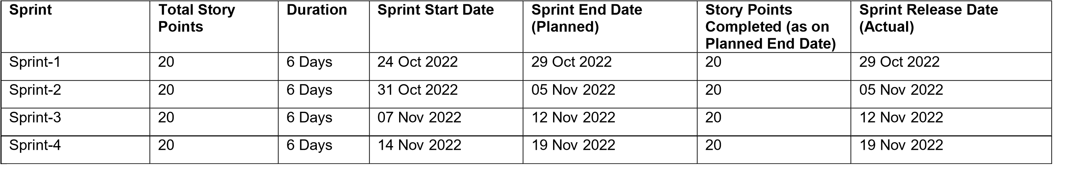

**Velocity:**

Imagine we have a 10-day sprint duration, and the velocity of the team is 20 (points per sprint). Let’s calculate the team’s average velocity (AV) per iteration unit (story points per day)

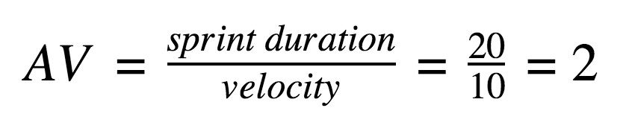

**Burndown Chart:**

A burn down chart is a graphical representation of work left to do versus time. It is often used in agile [software development](https://www.visual-paradigm.com/scrum/what-is-agile-software-development/) methodologies such as [Scrum.](https://www.visual-paradigm.com/scrum/scrum-in-3-minutes/) However, burn down charts can be applied to any project containing measurable progress over time.

